WORKSHEET 4

Student Name: Prateek Verma  Branch: MCA (CC & DEVOPS)  Semester: IIIrd  Subject Name: Technical Training | UID: 25MCC20062  Section/Group: 25MCC-101  Date of Performance: 21/09/2026  Subject Code: 25CAP-707

Experiment: Full Stack Integration of a Job Portal with MongoDB Database and JWT Authentication.
- Aim:
  - Transition a frontend-only React job portal into a full MERN stack application.
  - Develop a secure Node.js and Express backend to serve REST APIs for user authentication and job listings.
  - Implement robust password security using bcrypt hashing and manage user sessions via JSON Web Tokens (JWT).
  - Design and implement a MongoDB database using Mongoose schemas to persistently store user credentials and job data.
  - Integrate the React frontend to fetch and display dynamic database content using the useEffect hook, completely replacing hardcoded state.
- Prerequisites:
  - Visual Studio Code (VS Code).
  - Node.js installed on your system.
  - MongoDB Community Server and MongoDB Compass installed and running locally.
  - Postman for API testing.

- Implementation Steps:
- Backend project Setup:
  - Create a backend folder
  - Initialized the backend server using:
npm init -y
  - Installed required dependencies using:
npm install express mongoose cors bcryptjs jsonwebtoken dotenv
  - Configure a .env file in the backend directory to hold environment variables.

- Database and Schema configuration:
  - Specify the MONGO_URI in your .env file.
mongodb://127.0.0.1:27017/jobportal_db
  - Create a models folder containing User and Job schema.

- Implementing Authentication APIs:
  - Inside the Jobs.js router file, create a GET /api/jobs endpoint that queries Mongoose to find all job documents and return them sorted by newest first.
  - Created a POST /api/jobs endpoint to allow seeding new job listings into the database.

- Frontend React Integration:
  - Update the React form to capture email and password states.
  - Built a handleAuthentication function using the fetch API to send POST requests to the Express auth endpoints.
  - Use the useEffect hook in App.jsx to trigger an asynchronous fetch request to the GET /api/jobs endpoint as soon as the dashboard loads.

- Git Repository:
  - The entire code for the project can be accessed at:
https://github.com/Pkv0308/TechnicalTrainingSemII/tree/main/WS%203

- Output:
  - POST /restaurants
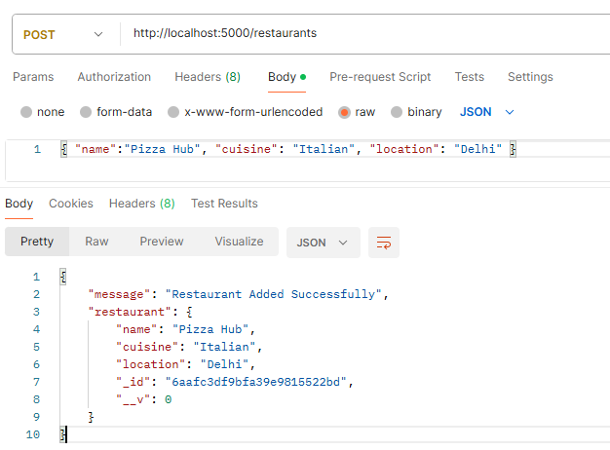
  - POST /menu
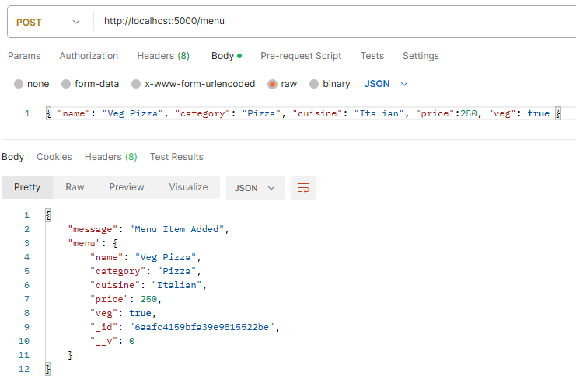
  - GET /menu/filter?veg=true
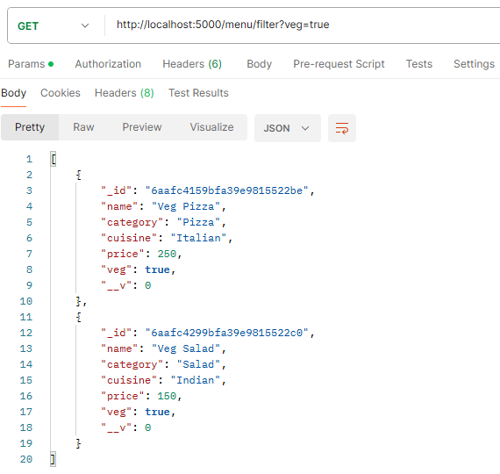

  - GET /menu/filter?minPrice=100&maxPrice=200
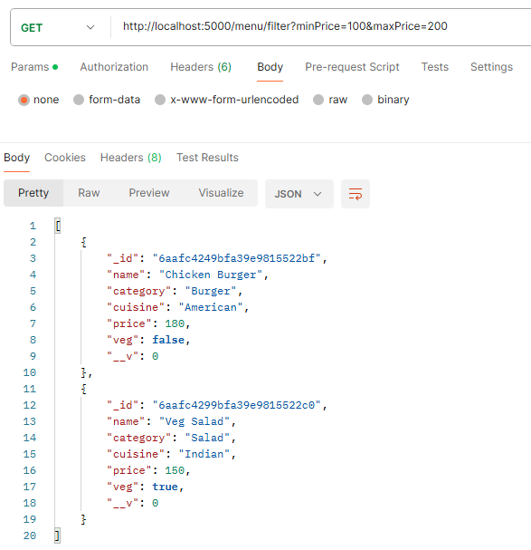
  - MongoDB: foodDeliveryDB>menus
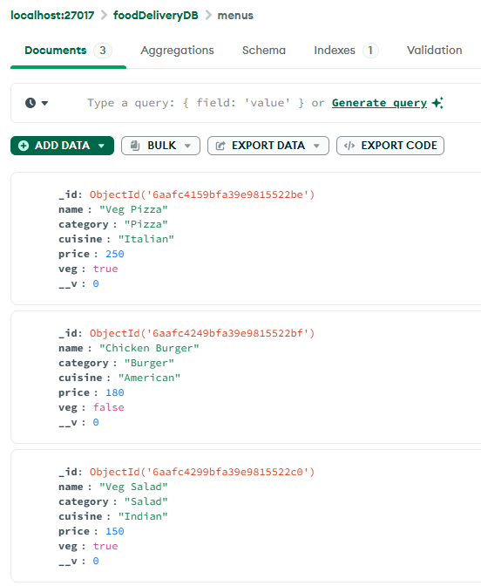

  - MongoDB: foodDeliveryDB>orders
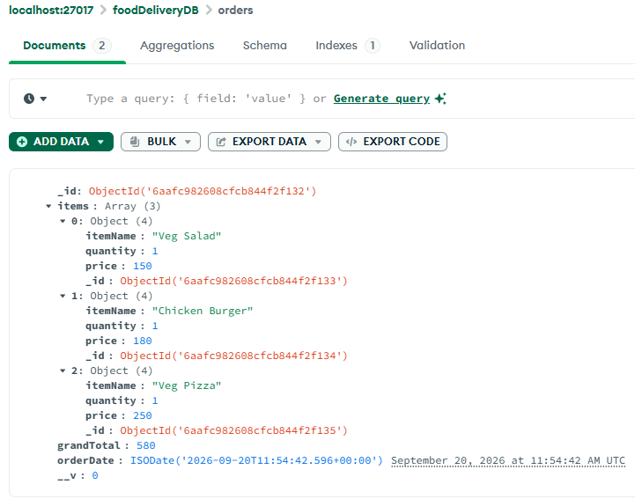
  - MongoDB: foodDeliveryDB>restaurants
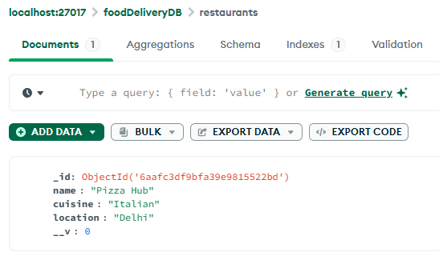

- Learning Outcomes:
  - Mastery of organizing a full-stack project structure separating client-side code from server logic.
  - Understanding of architectural trade-offs, specifically transitioning temporary cart data to localStorage while reserving MongoDB for permanent Orders.
  - Practical application of asynchronous JavaScript (fetch/await) to consume backend REST APIs and dynamically update the Document Object Model (DOM).
  - Demonstrated ability to utilize Express and Mongoose to create robust server-side routing and database schemas.
  - Improved understanding of client-side array manipulation (.reduce, .map, .filter) for real-time UI updates (e.g., live search and price sorting).

